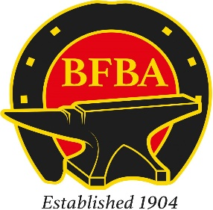****

BFBA National Championships 2024

Farriery Competition

**Judges**

Mr J Balfour AWCF

Mr DP Smith AWCF

Mr L Balfour DipWCF

**To Be Held At**

**Defence Animal Training Regiment**

**Ashfordby Road**

**Melton Mowbray**

**LE13 0HX**

Please note that entries close 3rd November 2023

**Saturday 23rd November**

This 'class' is open to those competitors with 1st, 2nd or 3rd placings in Open National and County Competition during the previous 3 years.

Each competitor in the Championship to be a current year BFBA member. A list of competitors and their strikers will be submitted to the BFBA office prior to the start of the Championship in order to check entry eligibility.

**Open Class:**

* **Each competitor to make, fit and nail on a Concave Hunter Fit shoe, toe clip front and quarter clipped hind on one allocated foot.**
* **Make one heavy horse hind shoe from 17½” x 1¼” x ½” with Calkins and plain stamped nail holes hammer drawn toe clip, size to suit.**
* **Make one deep seated fullered bar shoe 1½” – 6” wide 6½” long. No Tool striking another in the making of the clip, no flatters**
* **Time limit 75 minutes**
* **Striker allowed**

This class is open to 24 competitors on a first come first served basis.

Entry fee is £120. Please see entry form.

**Apprentice class:**

This 'class' is open to those competitors who are officially recorded as 1st, 2nd, 3rd or 4th year apprentices with the Farriers Registration Council.

* **Each apprentice competitor to make:**
* **Front straight bar shoe from 7/8” x 3/8” - 16½” fullered concave section**
* **Front deep seated open heel shoe plain stamped from 1” x ½” – 11½” flat section**
* **Time limit 50 minutes Apprentice**
* **Striker allowed**

This class is open to 24 competitors on a first come first served basis.

Entry fee is £30. Please see entry form

**Accommodation**

Premier Inn Melton Mowbray Hotel LE13 1JE

The Harboro Hotel - 01664 560121 LE13 1AF

Sysonby Knoll Hotel - 01664 563563 LE13 0HP

Quorn Lodge Hotel - 01664 5666660 LE13 0HR

Any questions please contact Adam Cooper on 07341 815763 or Mark Neal 07720 877839