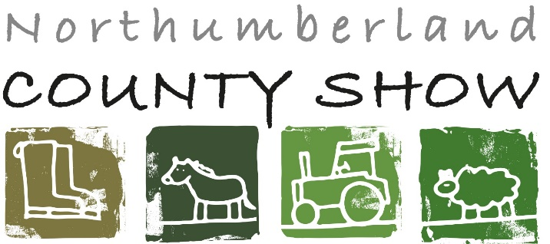

Northumberland County Show, held at Bywell, Stocksfield NE43 7AB

**SATURDAY 24th MAY 2025**

**FARRIERS ENTRY FORM**

Judge: MR MATT ARGO

**CLASS 1** **OPEN COB SHOEING**

¾ fullered on the foot and a specimen Entry Fee: £20

1st £100 2nd £50 3rd £25

**CLASS 2** **APPRENTICE SHOEMAKING**

Pair of plain stamped bevels Entry Fee; £10

Prizes in kind

**CLASS 3** **EAGLE EYE**

Open to all, enter on the day Entry Fee: £5

**ENTRIES CLOSE ON: 18th May 2025**  BACS: Sort Code: 40-24-16 Account No: 21149717 (Ref: Exhibitor Name / Farrier Comp). Northumberland County Show

.Send form to: debs.crozier@gmail.com

Telephone entries acceptable: 07793244277

Please enter me in Class _________ I have paid by BACS 🞎

Name ____________________________________________

Address ____________________________________________

Email address ____________________________________________

Telephone Number ____________________________________________

Signed ____________________________________________ Date ______________